HCI HOMEWORK RESOURCES

1. 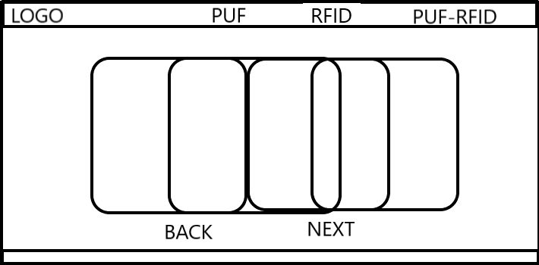When I first envisioned how the website will look, I was thinking that I will have 3 pages one for each of my main concepts, PUF, RFID and PUF based RFID, and I will be using multiple squared cards to display the information. My idea was to have the cards stacked on each other, you press the button next and the first card will grow bigger, cover the others and presents the information. You press next again and move to other card. The back button will follow the same idea.
2. I was thinking about using the next color pallet. But I realized that in my initial design I don’t have that many elements and using all of these colors and finding a balance between them will be hard.

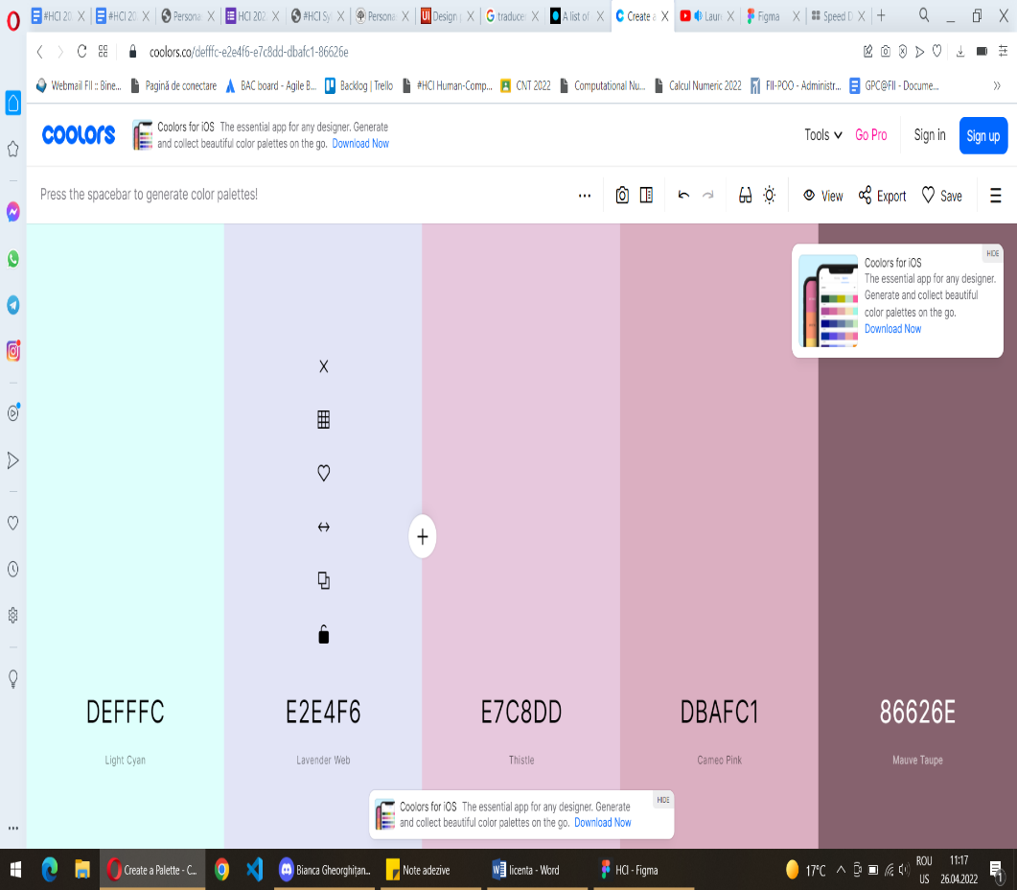

1. 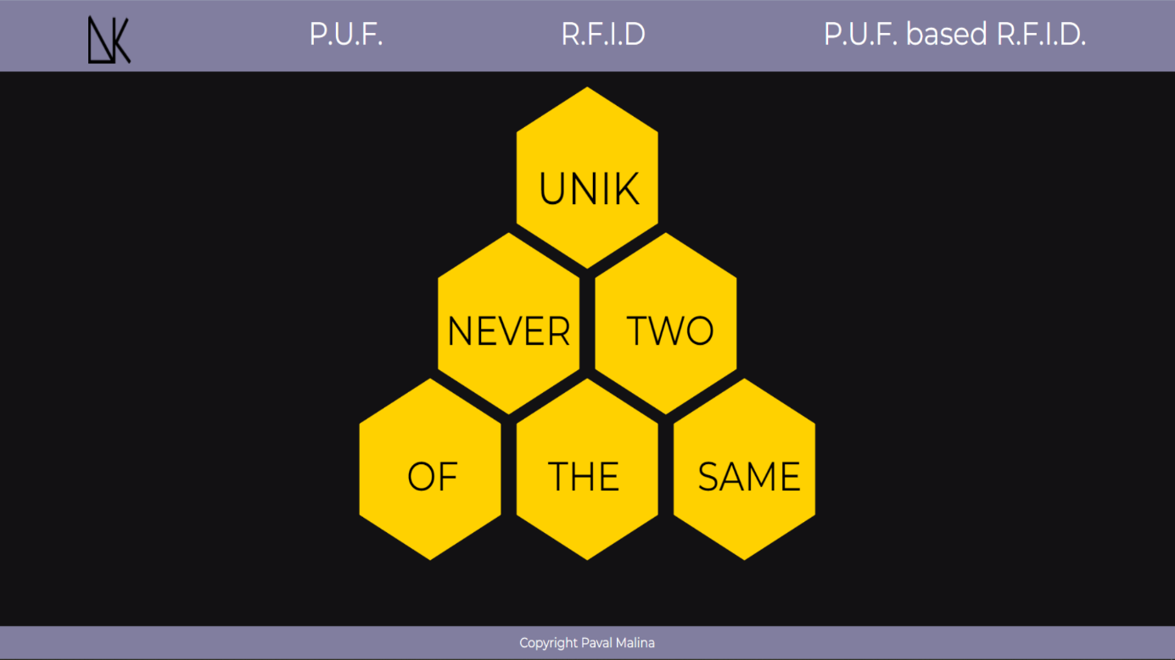I realized that I need a main page for the application, but didn’t know exactly what to place on it, so I thought about a motto. Using just a square for the page was really simple so I needed to rethink a bit my design. My thesis topic is based on PUFs and they use databases to store data, so I tried to create a visual metaphor for it and I thought that a honeycomb kind of resemblance the idea, it’s a compact structure in nature used to store the honey, so I redesigned the cards to be hexagonal. This is the idea for the main page. I also changed the color pallet from 5 in the beginning to three now. Firstly I was thinking about a combination of green shades, because I read that it’s a color that stimulates growth and concentration, but after I thought about the honeycomb idea I changed the colors to yellow, black and a shade of purple to create contrast between the content and the navigation bar and the footer.
2. 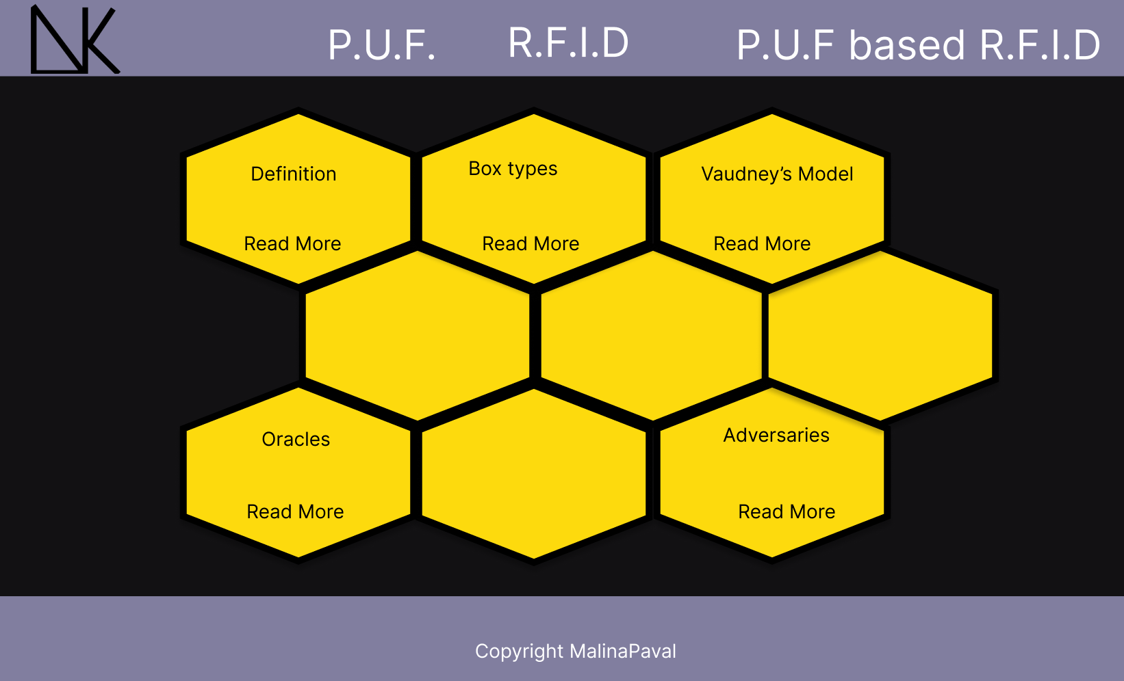When I adopted the honeycomb idea, I thought I will shape the cards to resemblance one. Later when I added the whole text I realized that the cards are too small to fit all the info even if I flip them around. So I decided that I will only create two rows of cards, so I can fit more information.

* The first interaction design pattern I will present is bond to navigation and is represented by the Navigation Tabs. The content of my thesis can be simply divided in three main topics, this is why I chose to represent these topics as section of the application and place them in the navigation bar, so the user can choose anytime another topic to study. Also, I kept the same structure (order) of the navigation tabs from page to page, so it will be easier for the user to adapt and the Navigation Tabs are persistent on all pages that the links lead to.
* Another pattern linked to navigation is represented by the Home Link. The logo of my application is linked to the main page giving the user the possibility to go back to the begging of the site in case it doesn’t want to read anymore. Also the home link is presented on all pages.
* When it comes to content, I chose to create Cards to display the information that the user my need from my application. The cards I used are hexagonal, because I tried to create the idea of a honeycomb. Additionally I rely on cards to deliver the data, because it’s a fast way for the user to find what he is interested in. Moreover, using cards helped me to provide the user with small parts of information at a time, it’s easier for a user to understand each concept that I presented when the information is fragmented in small portions.
* Moving to another design pattern, linked now to the user’s perception and memory, I exploited the Pattern Recognition one. I decided to keep the same design on all pages that presents information, 9 hexagonal cards placed in the middle that when the user hovers over them will flip and provide more information about that section, based on the idea that the user will recognize even from the first page how the cards works. If he wants to learn more about some of the card’s content he needs to hover, otherwise he will only see a part of the data and can move on to another one.
* Another design pattern, linked again to the user’s perception and memory, which concentrates now on the attention is the Reduction pattern. I tried to keep the design as simple as possible and tried to create a high contrast between the background that doesn’t provide information and the cards, so the user’s attention will be drown immediately to the important area of the site. In general, people are cognitively lazy, they like to receive the best result with a minimum effort, that is the reason I didn’t create another type of cards or others background animations, so the user can focus on exactly what he wants to learn.
* Questions, Options, Criteria

1. The first question I thought about when I started to design the application was how I am going to present the data to the user. Should I use a classical hierarchy like the one from Wikipedia, all information being presented in order, one beneath another or should I use something more intriguing for the user like a card? Even though the use of cards is pretty common in the websites today I tried to add a bit of originality in creating them and change their shape to a hexagon, so it could help me reach the honeycomb resemblance. The cards also enhance the user experience, no user wants to read all data from a site if it doesn’t help him in any way, and helped me organize the information in a hierarchy a bit different from the original one. The data is presented in order from the first row of cards to the second, each card being representative for a specific section of the page.
2. Another question was how I am going to organize the navigation. Should I use a dropdown menu, an accordion menu or just simply use some navigation tabs? The content of my application can be divided in 3 main section, each one with a pretty short name so I decided that using navigation tabs is the idea that suits the site the best, because if I would have chosen a dropdown menu that I would have placed in the right corner, my header would not have looked good, it would have seemed pretty empty.
3. Another question was what colors I should use for the application. I wanted to use as my base color green, I read that it is a color that promotes calmness and is also used to represent growth, I was thinking that my application can promote the information growth. I was going to use the monochromatic scheme to find others shade of green that will suit the site. After I came with the idea of the honeycomb I decided to change the colors and use yellow, it promotes happiness and increases the attention, black for the background to create contrast and highlight the cards and for the header and footer to use a shade of purple, but nothing that will contrast too much with the yellow.

* Personas

1. 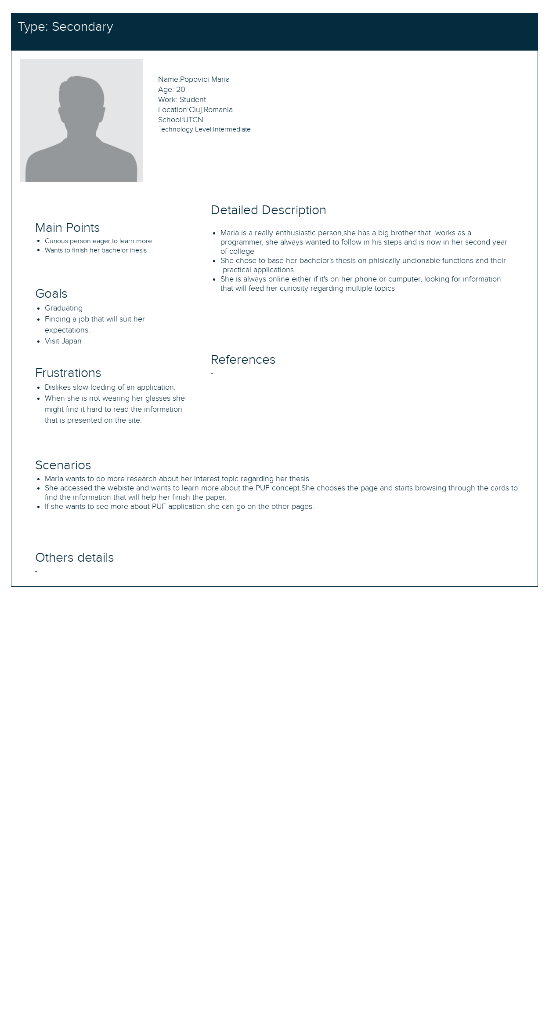Primary
2. Secondary
3. 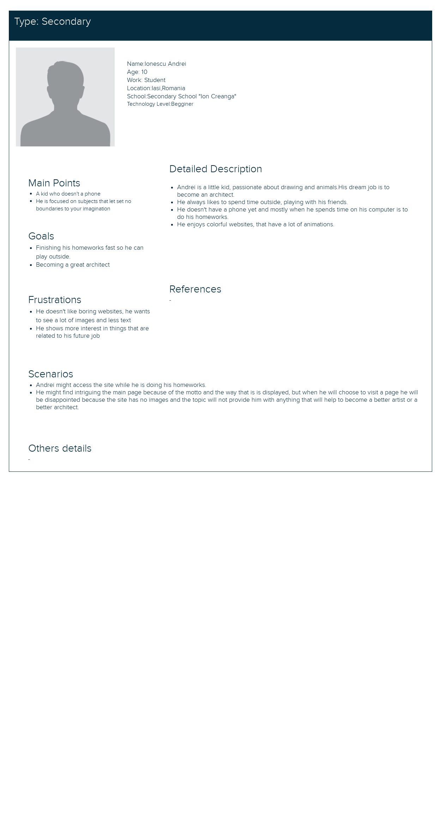Negative
4. Served

